LAB # 7
Generics in Java
OBJECTIVE:
Implementing generic classes and methods for ensuring compile time type safety of data.

Lab Task:
Write a program that takes integer array, double array and float array. Make a generic function that performs subtraction on array element:
Example: input intArray = [5, 7, 3, 9, 19]
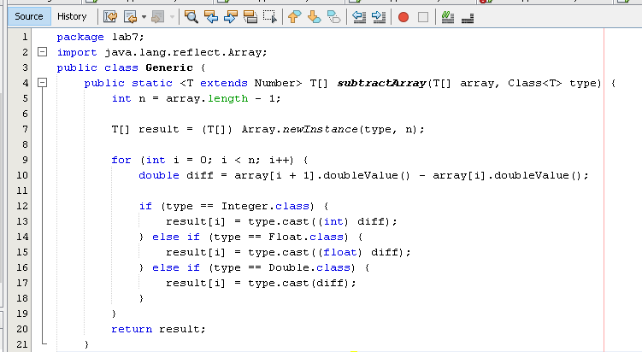
Output intArray = [2, -4, 6, 10]n

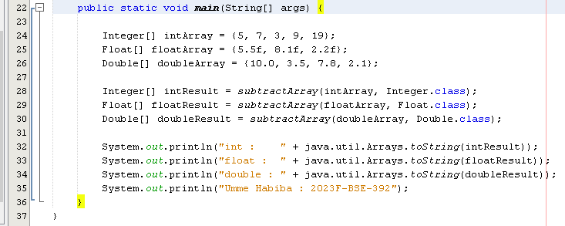

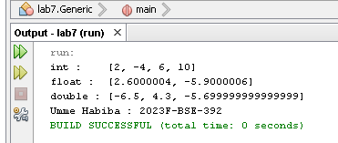
OUTPUT:

